January 25th, 2009
Hi
KUNG HEI FAT CHOY
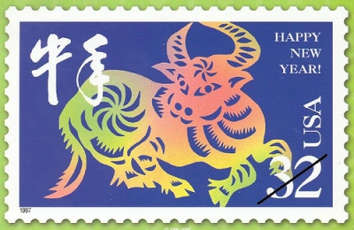
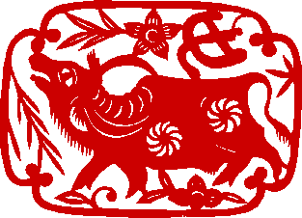

Today is New Year’s Day for the Year of the Ox. Nadine, you are an ‘Ox’ so I hope you stuck those red paper Year of the Ox strips I gave you onto your door, or if not, gave them to someone else to do so.

Last Sunday evening, after Gavin’s phone call, I went to the Tuen Mun Hospital A & E (Accident and Emergency). It was not very busy and no serious cases turned up while I was there, though I still had to wait a little while. As I mentioned, it turns out that I was not having a stroke, as there were not enough symptoms for this. Rather, it turned out to be Bell's palsy, with the left side of my face partially paralysed probably due to the sore throat I had (and which the CU doctor said was bacterial when it was actually viral, though both can lead to Bells’ palsy). I was given an appointment with an Ear and Throat (E & T) specialist later that Monday and to make an appointment with a physiotherapist. Got back about 0130 am.
The two main areas afflicted are my mouth area and my left eye. At first, I was unable to close my eye at all and my mouth looks rather like Stephen Hawking’s mouth making talking difficult. Both are slowly getting better.
When I saw the E & T specialist, he stuck endoscopes into my nostrils to examine my throat. He also said that on a scale of 0 to 6, where 6 is the worst, my affliction rated a 4 ~ 5 (though I think that is too severe). He then prescribed lots of medicines. This is included the anti-inflammatory drug prednisolone, which I am already familiar with as asthma medication. However, whereas I might need just a few tablets over a few days for the asthma, he told me to take 12 a day for a week and then to gradually taper it off. Whew – some inflammation! There was also medication for pain relief, Acyclovir tablets, Famotidine tablets (gastric relief), Vitamin 12 tablets, eye drops and eye ointment. I also got antacid tablets but have not taken any.
Two days later, I went to visit the physiotherapy in a new Rehabilitation block at the hospital. They showed me some facial massages I can do, which are repeated using ice. There is also a series of 8 exercises I can do. I do the massage and exercises five times a day. The main reason now for going to the clinic is for electrical stimulation of the face. At first it seemed useful, but now I am not so sure. During my second visit on Friday, the current was turned up more (as they said the more you can stand the better). However, I don’t think this helped. I remember some years ago at the CU clinic when I had similar treatment for an injured muscle, the e-stimulation, and especially at high levels, made the problem worse. So I stopped going and this helped.
There does seem to be some progress. I can now close my left eye, though only when I close both. However, the eye cannot blink. My mouth also looks slightly better. The E & T doctor said it may take a year for the damaged facial nerve to re-grow and the problem to disappear; I hope he is wrong.
I went to the gym again from Tuesday to Thursday. Did only a slightly reduced load though did the jogs were a little slower. And yesterday I decided to go for a shorter hike. And also slower (a) as my left eye vision was a little blurred so I did not want to trip and fall (I didn’t), (b) to nurse my Achilles tendon which is still not fully recovered and (c) just not to over-do things. My legs felt good though my breathing was a little laboured. However, at 1 h 45 min, it was actually faster than I had anticipated. Afterwards though, I felt very good. Cooler for the run (9⁰C) though this is not unexpected for this time of the year. Weekend runs have not been going well this season; only 7 so far compared with 12 by this date last year.
On Friday morning, there was a terrible accident near Lok Ma Chau (about halfway between here and Sheung Shui). A drunk container truck driver (4.5 times over limit!!) crossed the road and flattened a taxi killing its 6 occupants. Appalling! The container driver was unhurt!
Bird flu has again struck in China. A fourth person in just this month has died from it. And I heard on the news this morning that it has been detected on a farm in Vancouver, Canada.

On Tuesday, I stayed up to watch Obama's inauguration. I wasn’t going to but then decided it was a significant occasion. Awkward how the oath was muffed up due to the Chief Justice getting the word order wrong. So, it was probably a wise move for Obama to take the oath of office again the next day.
That’s about it for now.

Cheers

